COVID-19 Safety Plan for: South Park Elementary
Employers must develop a COVID-19 Safety Plan. To develop your plan, follow the six-step process described at
COVID-19 and returning to safe operation.
This planning tool will guide you through the six-step process. You may use this document, or another document that meets your needs, to document your COVID-19 Safety Plan.
Employers are not required to submit plans to WorkSafeBC for approval but, in accordance with the order of the provincial health officer, this plan must be posted at the worksite, and on the website if there is one. This Safety Plan can also be completed from any mobile device using the COVID-19 Safety Plan app.

Step 1: Assess the risks at your workplace
The virus that causes COVID-19 spreads in several ways. It can spread in droplets when a person coughs or sneezes. It can also spread if you touch a contaminated surface and then touch your face.
The risk of person-to-person transmission increases the closer you come to other people, the more time you spend near them, and the more people you come near.
The risk of surface transmission increases when many people contact the same surface and when those contacts happen over short periods of time.
Indicates acknowledgment of bullet
Involve workers when assessing your workplace
Identify areas where there may be risks, either through close physical proximity or through contaminated surfaces. The closer together workers are and the longer they are close to each other, the greater the risk.
We have involved frontline workers, supervisors, and the joint health and safety committee (or worker health and safety representative, if applicable).
We have identified areas where people gather, such as break rooms, production lines, and meeting rooms.
We have identified job tasks and processes where workers are close to one another or members of the public. This can occur in your workplace, in worker vehicles, or at other work locations (if your workers travel offsite as part of their jobs).
We have identified the tools, machinery, and equipment that workers share while working.
We have identified surfaces that people touch often, such as doorknobs, elevator buttons, and light switches.

Step 2: Implement protocols to reduce the risks
Select and implement protocols to minimize the risks of transmission. Look to the following for information, input, and guidance:
Review industry-specific protocols on worksafebc.com to determine whether any are relevant to your industry. Guidance for additional sectors will be posted as they become available. If protocols are developed specific to your sector, implement these to the extent that they are applicable to the risks at your workplace. You may need to identify and implement additional protocols if the posted protocols don’t address all the risks to your workers.
Frontline workers, supervisors, and the joint health and safety committee (or worker representative). Orders, guidance, and notices issued by the provincial health officer and relevant to your industry. Your health and safety association or other professional and industry associations.

Different protocols offer different levels of protection. Wherever possible, use the protocol that offers the highest level of protection. Consider controls from additional levels if the first level isn’t practicable or does not completely control the risk. You will likely need to incorporate controls from various levels to address the risk at your workplace.
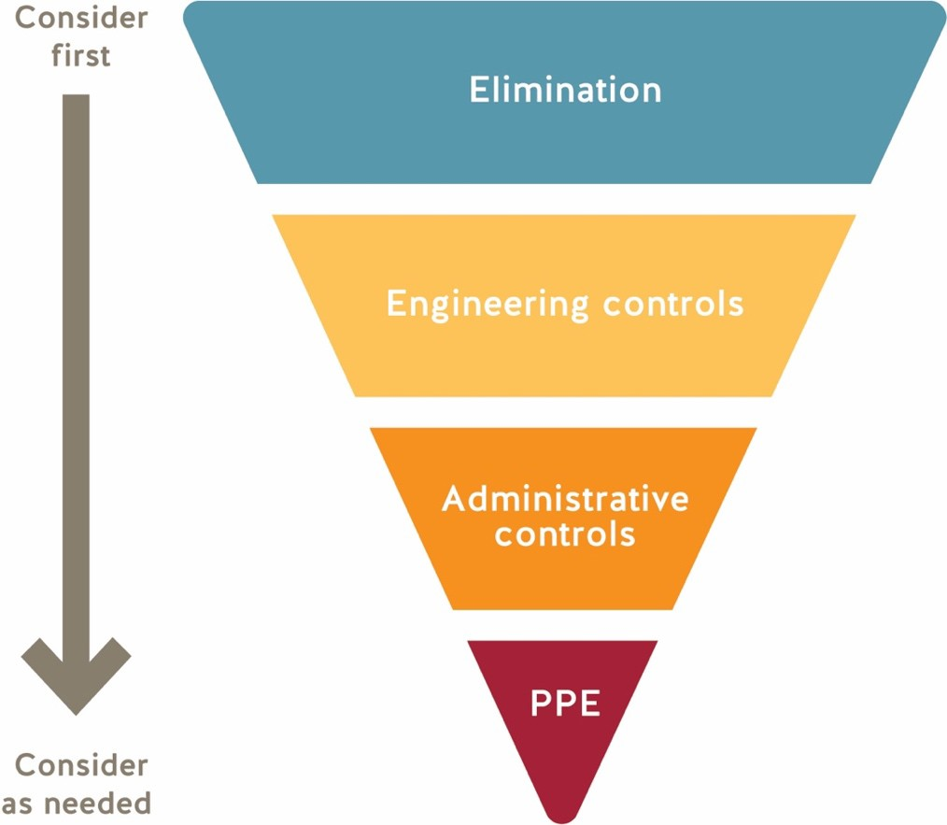

First level protection (elimination) — Limit the number of people in your workplace where possible by implementing work-from-home arrangements, establishing occupancy limits, rescheduling work tasks, or other means. Rearrange work spaces to ensure that workers are at least 2 m (6 ft.) from co-workers, customers, and members of the public.
Second level protection (engineering controls) — If you can’t always maintain physical distancing, install barriers
such as plexiglass to separate people.
Third level protection (administrative controls) — Establish rules and guidelines, such as posted occupancy limits for shared spaces, designated delivery areas, cleaning practices, and one-way doors and walkways to keep people physically separated.
Fourth level protection (PPE) — If the first three levels of protection aren’t enough to control the risk, consider the use of masks. Ensure masks are selected and cared for appropriately and that workers are using masks correctly.

First level protection (elimination): Limit the number of people at the workplace and ensure physical distance whenever possible
We have established and posted an occupancy limit for our premises. Public Health has advised that the prohibition on gatherings of greater than 50 people refers to “one-time or episodic events” (weddings, public gatherings), and is therefore not intended to apply to workplaces. However, limiting the number of people in a workplace is an important way to ensure physical distancing is maintained. [Public Health has developed guidance for the retail food and grocery store sector that requires at least 5 square metres of unencumbered floor space per person (workers and customers). This allows for variation depending on the size of the facility and may be a sensible approach for determining maximum capacity for employers from other sectors that do not have specific guidance on capacity from Public Health.]
In order to reduce the number of people at the worksite, we have considered work-from-home arrangements, virtual meetings, rescheduling work tasks, and limiting the number of visitors in the workplace.
We have established and posted occupancy limits for common areas such as break rooms, meeting rooms, change rooms, washrooms, and elevators.
We have implemented measures to keep workers and others at least 2 metres apart, wherever possible. Options include revising work schedules and reorganizing work tasks.
Measures in place

Describe the physical distancing measures at your school/site. Consider the following items:

- Arrangement of workstations/furniture to allow physical distancing
We have arranged furniture in common rooms such as the Staff Room to be physically distanced.
We have arranged student desks and tables to be as distanced as possible and not facing each other.
- Delineation of flow in high traffic areas (one way marking, separated two-way travel, use of additional entrances/exits)
Number of students in hallways will be limited.
We have arrows showing hallway directions and have encouraged staff and students to use exterior classroom doors more frequently to move about the school.
Restricted the number of people in the school office.
- Redistribution of staff to other locations
Some non-enrolling teachers have altered their schedules to reduce the number of staff in the building as well as limiting their own contact numbers.
- Visitor policy - unnecessary visitors prohibited from entering
Parents are no longer allowed in the school and all other visitors must sign in and sign off on a Daily Health Check.
- Use of virtual meetings, discontinuing of assemblies/group gatherings
There are no assemblies of students and monthly staff meetings happening. Assemblies and Staff meetings are now being held virtually.
- Changes to how routine tasks are completed
Only one staff member in photocopy room at a time and the machine is wiped down after every use.
Appliances in the staff room have either been removed or are wiped down after each use.
- Occupancy limits for common/shared rooms areas (e.g, lunchrooms, meeting rooms, washrooms, etc.)
Occupancy limits have been posted on all common rooms.

Second level protection (engineering): Barriers and partitions
We have installed barriers where workers can’t keep physically distant from co-workers or students.
We have included barrier cleaning in our cleaning protocols. Barriers are being cleaned at least once per day.
Measures in place

Describe use of physical barriers (fixed and portable) at your school/site

- Administration Offices
Physical barrier is in place between the school admin assistant and people entering the office (also restricted).
- Common workspaces
Physical barriers have been offered to all teachers.
- Counselling offices
Physical barriers are in place in counselors’ office

Third level protection (administrative): Rules and guidelines
We have identified rules and guidelines for how workers should conduct themselves.
We have clearly communicated these rules and guidelines to workers through a combination of training and signage.
Measures in place

- Requirement for staff and students to perform Daily Health Check prior to arriving each day.

- Sign-in Process for non-regular staff/contractors/visitors.

- Hand hygiene instructions (hand washing/alcohol-based sanitizer)

- Program specific COVID-19 precautions
  - Music -all students will be spaced as much as possible
  - Library -all students spaced as much as possible and behind barriers
  - PE -students will sanitize hands upon entering the gym
-students and teachers will wear masks during PE class
-high intensity games will be played outside as much as possible
-Recess -students will sanitize hands upon going outside and coming inside

- Procedures/PPE for First Aid Attendants

- Communication processes and procedures

Fourth level protection: Using masks
We have reviewed the information on selecting and using masks and instructions on how to use a mask.
We have offered to supply Staff with a KN 95 mask if needed.
We have trained workers in the proper use of masks.
Measures in place

District mask policy is that staff must wear masks in all common spaces including:

-classrooms
- hallways
- photocopy/ work rooms
- 2 or more people traveling in vehicles
- lunchrooms where physical distancing cannot be maintained

Implement effective cleaning and hygiene practices
We have reviewed the information on cleaning and disinfecting surfaces.
Our workplace has enough handwashing facilities on site for all our workers. Handwashing locations are visible and easily accessed.
We have policies that specify when workers must wash their hands and we have communicated good hygiene practices to workers. Frequent handwashing and good hygiene practices are essential to reduce the spread of the virus.
We have implemented cleaning protocols for all common areas and surfaces — e.g., washrooms, tools, equipment, vehicle interiors, shared tables, desks, light switches, and door handles. This includes the frequency that these items must be cleaned (number of times per day) as well as the timing (before and after shift, after lunch, after use).
Workers who are cleaning have adequate training and materials.
We have removed unnecessary tools and equipment to simplify the cleaning process — e.g., coffee makers and shared utensils and plates
Cleaning protocols

Reference District "Enhanced Cleaning and Disinfecting" protocols and typical cleaning and disinfecting tasks to be completed by District custodial staff.

- Include site specific information on daily custodial schedule:
  - daytime custodial schedule 11:00AM-2:00PM
  - evening custodial schedule 3:00PM-11:00PM and 5:00PM-11:00PM

- Include information on cleaning/disinfecting tasks that are NOT completed by District custodial staff that must be completed by school/site staff.
  - lunch/break areas (both custodian and staff after use)
  - workstation surfaces/offices (both custodian and student cleaning between classes)
  - shared classroom/learning items (teachers and students cleaning after use)

Step 3: Develop policies
Develop the necessary policies to manage your workplace, including policies around who can be at the workplace, how to address illness that arises at the workplace, and how workers can be kept safe in adjusted working conditions.
Our workplace policies ensure that workers and others showing symptoms of COVID-19 are prohibited from the workplace.
Anyone who has had symptoms of COVID-19 must follow directions as outlined by BCCDC. Anyone directed by Public Health to self-isolate.
Anyone who has arrived from outside of Canada must self-isolate for 14 days and monitor for symptoms. Visitors are prohibited or limited in the workplace.
First aid attendants have been provided OFAA protocols for use during the COVID-19 pandemic.
We have a work from home policy in place (if needed).
Ensure workers have the training and strategies required to address the risk of violence that may arise as customers and members of the public adapt to restrictions or modifications to the workplace. Ensure an appropriate violence prevention program is in place.
Our policy addresses workers/ students who may start to feel ill at work. It includes the following: Sick workers/ students should report to first aid, even with mild symptoms. Workers and students will be sent home as soon as possible.
Sick workers should be asked to wash or sanitize their hands, provided with a mask, and isolated. Ask the worker to go straight home.
If the worker is severely ill (e.g., difficulty breathing, chest pain), call 911. Clean and disinfect any surfaces that the ill worker has come into contact with.

Step 4: Develop communication plans and training
You must ensure that everyone entering the workplace, including workers from other employers, knows how to keep themselves safe while at your workplace.
We have a training plan to ensure everyone is trained in workplace policies and procedures. All workers have received the policies for staying home when sick.
We have posted signage at the workplace, including occupancy limits and effective hygiene practices.
We have posted signage at the main entrance indicating who is restricted from entering the premises, including
visitors and workers with symptoms.
Supervisors have been trained on monitoring workers and the workplace to ensure policies and procedures are being followed.

Step 5: Monitor your workplace and update your plans as necessary
Things may change as your business operates. If you identify a new area of concern, or if it seems like something isn’t working, take steps to update your policies and procedures. Involve workers in this process. Reviewing and updating your COVID-19 safety plan: A guide for employers will help you review your safety plan to ensure it's effective and functioning properly.
We have a plan in place to monitor risks. We make changes to our policies and procedures as necessary. Workers know who to go to with health and safety concerns.
When resolving safety issues, we will involve joint health and safety committees or worker health and safety representatives (or, in smaller workplaces, other workers).

Step 6: Assess and address risks from resuming operations
If your workplace has not been operating for a period of time during the COVID-19 pandemic, you may need to manage risks arising from restarting your business.
We have a training plan for new staff.
We have a training plan for staff taking on new roles or responsibilities.
We have a training plan around changes to our business, such as new equipment, processes, or products.
We have reviewed the start-up requirements for vehicles, equipment, and machinery that have been out of use. We have identified a safe process for clearing systems and lines of product that have been out of use.

Be advised that personal information must not be included in the COVID-19 Safety Plan
Personal information is any recorded information that uniquely identifies a person, such as name, address, telephone number, age, sex, race, religion, sexual orientation, disability, fingerprints, or blood type. It includes information about a person’s health care, educational, financial, criminal, or employment history. Visit https://www.oipc.bc.ca/about/legislation/ for more information.

